Predict Football Match Outcomes

1- Data Input

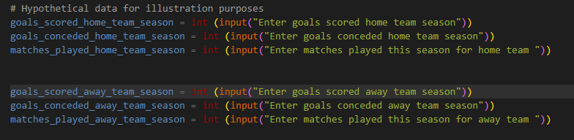The user is prompted to input data for both home and away teams, including the goals scored, matches played, goals conceded, etc.

2- **Functions**

* **calculate_average_goals**: Calculates the average goals per match based on the total goals scored and matches played.
* 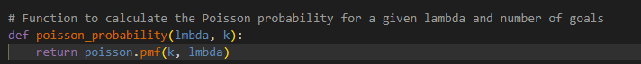**poisson_probability**: Calculates the Poisson probability for a given lambda and number of goals using the **pmf** (probability mass function) from the **scipy.stats.poisson** module.
* **predict_match_outcome**: Predicts match outcomes and the number of goals based on the average goals scored and conceded by both home and away teams.

**3-Prediction:**

* The script calculates the average goals scored and conceded for both the home and away teams using the provided data.
* It then uses the Poisson distribution to calculate the probabilities of different goal combinations for home and away teams.



* The script prints the probabilities of a home win, away win, and draw, and predicts the match result based on the highest probability.

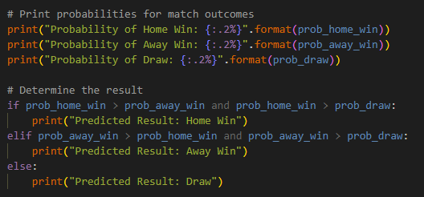

* Additionally, it predicts the number of goals for both the home and away teams.

